**For While Do while Break Continue Assignment**

**WAP to read a number n and to display the cumulative sum of factorial of all numbers upto n . (use for or while)**

Input: 4

Ouput: 4!+3!+2!+1! = 32

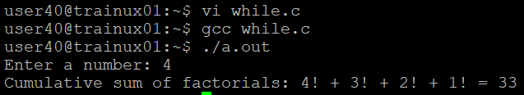

**2. Write a program to accept “N” integers from the user. “N” also has to be taken from the user. Take the count of +ve numbers, -ve numbers and 0’s.**

However the program should not accept a non-integer value. If a non-integer value is entered, used must be asked to re-enter.

[Hint:

a**. Use the return value of scanf to find out whether the user has entered integer or not.**

**b. You also will have to clear the input buffer before taking the next input.**

**For clearing the input buffer, use one of the following approaches**

**while (getchar() != '\n'); // keep reading till newline and discard the characters**

**scanf(“%*s”); // read and discard one string**

]

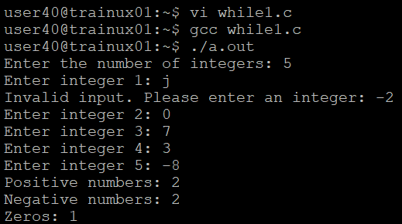

3**. Write a program to continuously read a string of maximum length 80 chars, End the program if string is END, else convert to upper case, display and continue. (use while)**

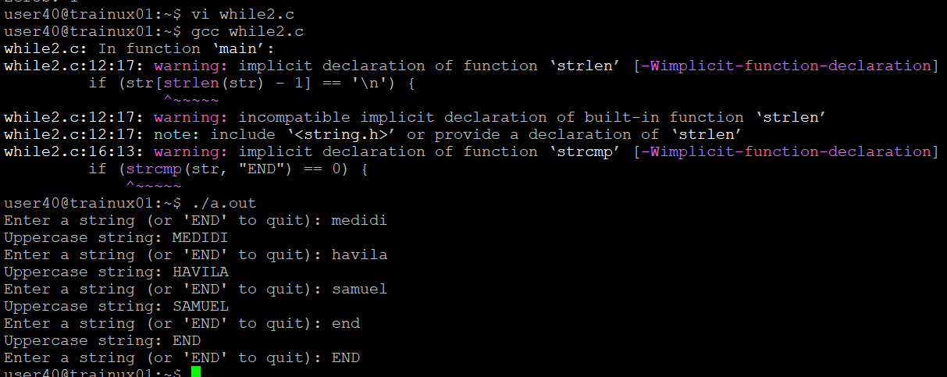

**4. Refer the program “value_out_of_domain.c”. Try to run the program with a large value say 255. Check the output? Is it correct? Fix the issue observed.**

**What improvements do you suggest?**

* 20! is 2,432,902,008,176,640,000, which fits into unsigned long long.
* But 255! is much larger, and the result would exceed the storage limits of unsigned long long, causing incorrect results or overflow

The factorial of 255 is a huge value which cannot be stored in int type which holds only 4 bytes with a range of -2,147,483,648 to 2,147,483,647. So store such a large values we need to define an array with large size like array[1000] that holds the value

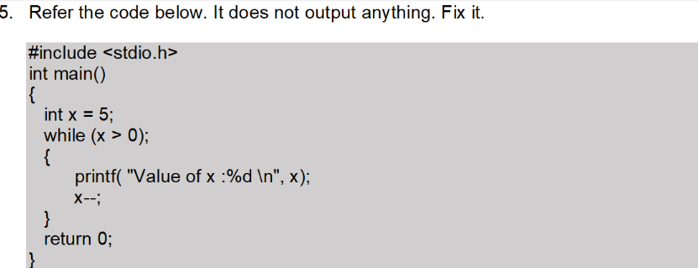

The original code has a semicolon (;) after the while loop condition, causing the body of the loop to be skipped, and the loop effectively does nothing.

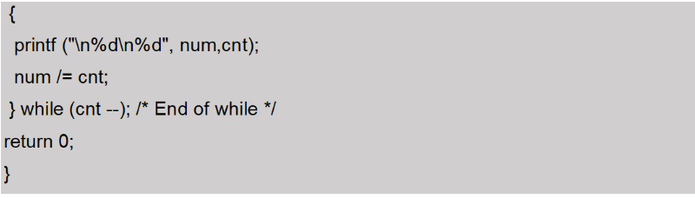

The variables cnt and num are declared as floats but they are given format specifiers as %d. It can be rectified by taking %f as format specifiers.

